MSCF Python Programming Basics
Homework 3

Due At 11:59 pm US Eastern Daylight Time,
Wednesday, July 21, 2021

- (10 points) Reading from expenses.txt

  - Using open() and close()

In Homework 2, we asked you to process a list of str values describing business expenses to produce a report in this format:

1 Amount Category Date Description
2 5.25 supply 20170222 box of staples
...
30 284.23 util 20170323 Peoples Gas
31 8.98 supply 20170325 Flair pens

The expenses list in Homework 2 was hard-coded, which is not realistic.

Make a copy of your Homework 2 code file into a new file named hw3_1_a.py. Update the File and Author(s) comments at the top of hw3_1_a.py:

# File: hw3_1_a.py
# Author(s): ... HW3 team member names here ...

In the code, modify expenses to be an empty list, then read lines from the expenses.txt file (excluding the terminating newline characters) and append them to the expenses list. Modify the remainder of the code to produce just the final requested report, as illustrated above. Save and test.

Make sure to save your hw3_1_a.py code file to submit as part of this homework.

  - Using with open()

A problem with using open() and close() with a file is that it’s very easy to forget to call close() (even if you have been writing code for years!).

As an alternative to this code:

fin = open('infile.txt', 'rt', encoding = 'utf-8')
for line in fin:
... do something with each input line ...
fin.close() # need explicit close() call

print('Done with infile.txt')

you can use a with open() block of code so that close() occurs automatically, like this:

with open('infile.txt', 'rt',
encoding = 'utf-8') as fin:
for line in fin: # indented block
... do something with each input line ...
# close() is automatic at end of block!

print('Done with infile.txt')

Make a copy of hw3_1_a.py named hw3_1_b.py. Update the File comment:

# File: hw3_1_b.py
# Author(s): ... HW3 team member names here ...

Instead of open() and close() of the expenses.txt file, use a with open() block. Save and test, to confirm that this works correctly.

- (20 points) Collection Construction and Comprehension

Using the IDE of your choice, edit the hw3_2.py code file provided with this homework assignment. Update the Author(s) comment with the names of your homework team members.

  - Below the comments, the code defines a variable s1 to refer to the str value "Choo Choo Ch'Boogie". Uncomment the print(s1) function call for part 2.a, then save and test to confirm that the value of s1 is displayed.

  - Using list construction (that is, the list() function with an iterable argument), define a variable m1 to refer to a list of the one-character substrings of s1, where the one-character substrings in m1 occur in the same order as the characters in s1. Uncomment the print(m1) function call for part 2.b, then save and test.

  - Using set construction, define a variable set1 to refer to a set of the unique one-character substrings of m1. Uncomment print(set1); save and test.

  - Using an appropriate sequence of constructions and other methods, define a variable t1 to refer to a tuple of the unique one-character substrings from set1, in ascending (non-descending) order. Uncomment print(t1); save and test.

  - The code for part 2.e defines a variable s2 to refer to the str value "the quick brown fox jumps over the lazy dog". Uncomment print(s2); save and test.

  - Using an appropriate method, define a variable m2 to refer to a list of the words from s2. That is, m2 should refer to ['the', 'quick', 'brown', …, 'lazy', 'dog']. Uncomment print(m2); save and test.

  - Using dict construction and either zip() or enumerate(), define a variable d1 that refers to a dict in which the keys are int indexes starting from 1, and the values are the words from m2. Uncomment print(d1); save and test.

  - Write a for loop using multiple assignment that displays the keys and corresponding values from d1, like this:

1: the
2: quick
3: brown
4: fox
5: jumps
6: over
7: the
8: lazy
9: dog

Save and test.

  - Write a list comprehension that defines a variable m3 to refer to a list of the one-character substrings of s2. Uncomment print(m3); save and test.

  - Write a list comprehension that defines a variable m4 to refer to a list of the one-character substrings of s2 except for spaces (that is, the list should not contain any ' ' values). Uncomment print(m4); save and test.

  - Write a set comprehension that defines a variable set2 to refer to a set of the unique one-character substrings of s2 except for spaces. Uncomment print(set2); save and test.

  - Using a list comprehension followed by another method, define a variable m5 that refers to a list of the unique one-character substrings of set2, in ascending (non-descending) order. Uncomment print(m5); save and test.

  - Write a dict comprehension that defines a variable d2 in which the keys are lowercase letters (one-character strings) in ascending order, and the corresponding values are 0. Write a for loop using multiple assignment that displays the keys and corresponding values from d2, like this:

a: 0
b: 0
c: 0
...
y: 0
z: 0

Save and test.

  - Recall that an open file is iterable. Using with open(), open the expenses.txt file for reading, then write a list comprehension that defines a variable m6 to refer to a list of the lines (strings) from the expenses.txt file, with the terminating newline character eliminated from each line. Uncomment print(m6); save and test.

  - Write nested for loops that step through each line in m6 and each one-character substring in each line and, if the one-character substring is a key in d2, increments the corresponding value for that key. Then, write a for loop using multiple assignment that displays the keys and corresponding values from d2, like you did in part 2.m, above. (This will display each lowercase letter and the count of occurrences of that lowercase letter in the expenses.txt file.) Save and test.

- (70 points) Commodity Futures and Option Contracts

Commodity futures and option contracts of many kinds are traded on NYMEX, owned by CME Group. Each evening of each trading day, sometime between about 6:00 pm and 8:00 pm U.S. Central Time, a SPAN (Standard Portfolio Analysis of Risk) file is posted to cmegroup.com/ftp/span/data/cme containing information about the day’s trading. For a given day, the name of this file is cme.YYYYMMDD.c.pa2.zip, where YYYYMMDDD is the 8-digit year, month, and day of the file. Files for months prior to the current month are moved into a subdirectory of cmegroup.com/ftp/span/data/cme.

Download the zipped SPAN file for Friday, July 9, 2021, cme.20210709.c.pa2.zip. (To do the download yourself, you will need to register for a free account on the CME Group web site. If you would prefer not to do that, you may download the copy of cme.20210709.c.pa2.zip from Canvas.) Unzip, then display this SPAN file. You will see that it is an enormous text file (nearly one million lines) with its own idiosyncratic format—unfortunately not something simple and convenient like CSV or XML or JSON.

The settlement prices contained in the SPAN file are used to mark to market each trader’s account, so that gains/losses can be credited/debited each day to reduce the risk of counterparty default. Your job is to extract these settlement prices, as well as contract expiration dates (last trading dates), for two of the most heavily traded energy contracts: West Texas Intermediate (WTI) Crude Oil, and Henry Hub Natural Gas.

To learn more about WTI Crude Oil futures contract details, examine this web site: http://www.cmegroup.com/trading/energy/crude-oil/light-sweet-crude_contract_specifications.html

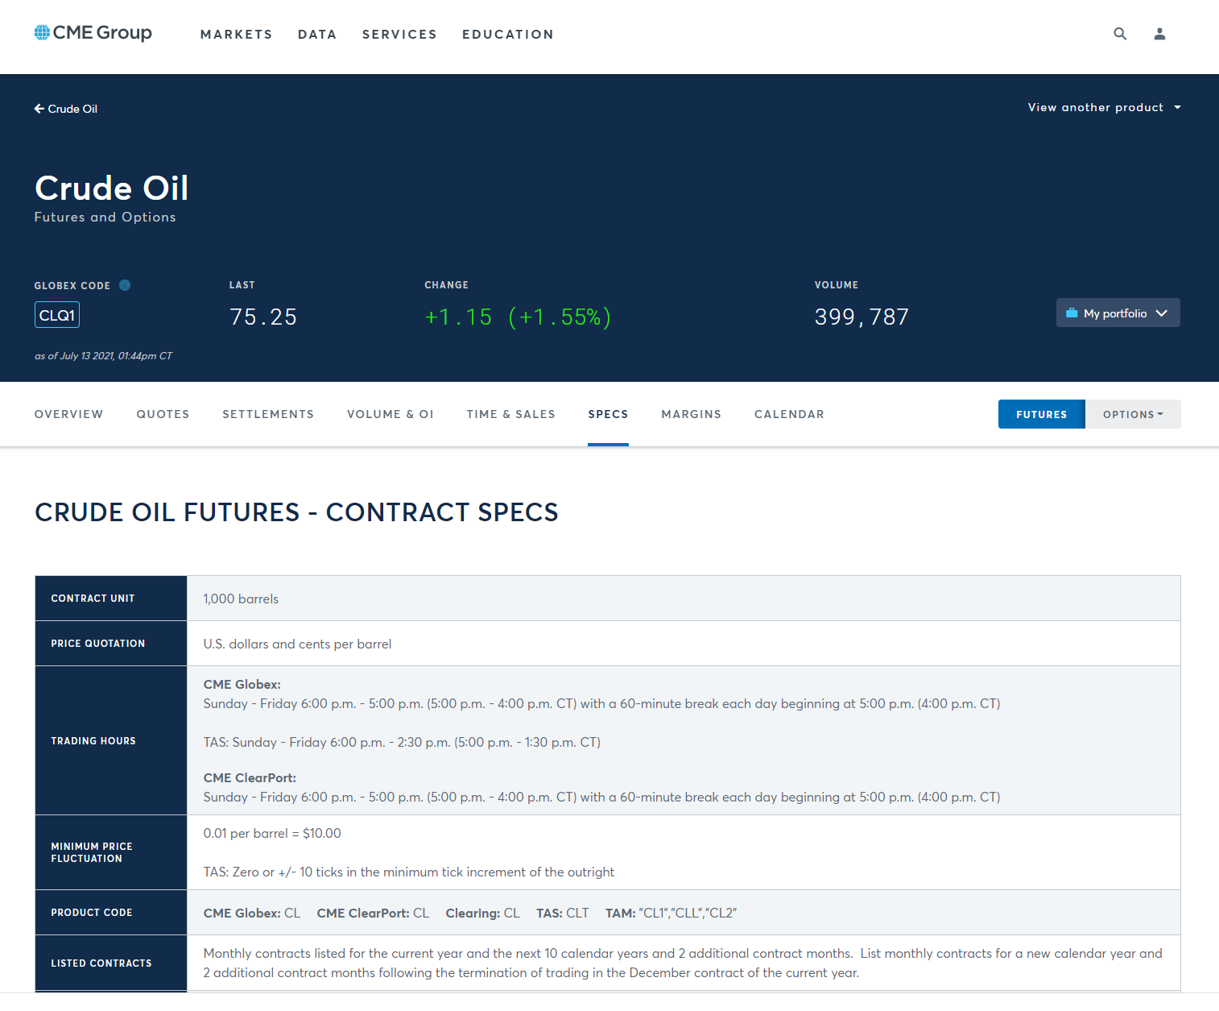

Notice that the CME Globex Product Code is CL; you will need this for scanning the SPAN file. Using other tabs at the top of this page, you can see current quotes, recent settlements, volume, etc. If you click the Options button just to the right of the Futures button at right, you will see information about option contracts based on the underlying futures contracts. There are about two dozen different types of option contracts for this underlying; we are interested in the American Options. When you look at the contract specifications, you will discover that its CME Globex Product Code is LO.

Return to the Futures page. In the View Another Product menu at upper right, scroll down and select NG – Natural Gas (Henry Hub) Physical Futures to learn about natural gas futures contracts and the corresponding American option contracts.

Write a Python program named hw3_3.py that reads cme.20210709.c.pa2 as its input file, and produces CL_and_NG_expirations_and_settlements.txt as its output file. The output should be in exactly this form:

Futures Contract Contract Futures Options Options
Code Month Type Exp Date Code Exp Date
------- -------- -------- -------- ------- --------
CL 2021-09 Fut 2021-08-20
CL 2021-10 Fut 2021-09-21
… and so forth, through contract month 2023-12 …
CL 2023-12 Fut 2023-11-20
CL 2021-09 Opt LO 2021-08-17
CL 2021-10 Opt LO 2021-09-16
… and so forth, through contract month 2023-12 …
CL 2023-12 Opt LO 2023-11-15
NG 2021-09 Fut 2021-08-27
NG 2021-10 Fut 2021-09-28
… and so forth, through contract month 2023-12 …
NG 2023-12 Fut 2023-11-28
NG 2021-09 Opt ON 2021-08-26
NG 2021-10 Opt ON 2021-09-27
… and so forth, through contract month 2023-09 …
NG 2023-09 Opt ON 2023-08-28
Futures Contract Contract Strike Settlement
Code Month Type Price Price
------- -------- -------- ------ ----------
CL 2021-09 Fut 73.81
… and so forth, through contract month 2023-12 …
CL 2023-12 Fut 58.96
CL 2021-09 Call 0.50 73.36
CL 2021-09 Put 0.50 0.01
CL 2021-09 Call 1.00 72.86
CL 2021-09 Put 1.00 0.01
… and so forth, through contract month 2023-12 …
CL 2023-12 Call 210.00 0.03
CL 2023-12 Put 210.00 151.00
NG 2021-09 Fut 3.657
NG 2021-10 Fut 3.660
… and so forth, through contract month 2023-12 …
NG 2023-12 Fut 2.926
NG 2021-09 Call 0.250 3.407
NG 2021-09 Put 0.250 0.001
NG 2021-09 Call 0.500 3.157
NG 2021-09 Put 0.500 0.001
… and so forth, through contract month 2023-09 …
NG 2023-01 Call 4.000 0.174
NG 2023-01 Put 4.000 0.895
NG 2023-09 Call 1.800 0.937
NG 2023-09 Put 1.800 0.059
Do not try to create a better output format: it needs to be very easy for us to compare your output to our solution output, and to other students’ outputs. We will take off points if your output format varies too much from what is shown above. Our output format takes into account the order in which records appear in the SPAN file, so you don’t have to remember or accumulate too much information as you go. In particular, your program only needs to read through the input file one time.

Do not include contract months earlier than 2021-09, or later than 2023-12. Notice that Natural Gas options are not yet available for every month in 2023.

Since there are many, many strike prices for options on futures contracts, the output file is going to be very long (over 15400 lines), but not nearly as long as the SPAN file itself.

Fortunately, there is documentation online that describes the contents of CME SPAN files. If you Google for “cme span pa2 file format” you will find a page named “Risk Parameter File Layouts for the Positional Formats – SPAN…”. You will want to look at Type “B” Records, Expanded Format, and Type “8” Records, Expanded Format, to learn how to obtain the contract name, type, month, expiration date, strike, and settlement prices that you need. (The field names in the output file are not identical to the corresponding field names in the SPAN file documentation. The output file is intended to be read by finance people; the SPAN file documentation is intended to be read by computer geeks. You will need figure out how to be both.)

A few hints:

(a) Notice that the documentation counts character column positions from 1, whereas in your code you will need to count character positions from 0 for string slicing or other purposes

(b) Check the contract specifications to discover the number of decimal places you should display for prices of different commodity futures and options contracts.

(c) You will discover that the documentation is not quite perfect, but you should be able to figure out any problem(s) you encounter. (Big hint: talk to others.)

(d) Approach the program in stages: first, make sure you can write a program that simply copies the SPAN file to the output file; next, modify your program to copy just the type B and type 8 records from the SPAN file to the output file; next, modify your program to copy the type B and type 8 CL records; next, the type B and type 8 CL and NG records; and so forth, making definite steady progress toward your eventual goal with each revision of your code. As your coding skills improve, you can do two or three or four things in each revision step. Eventually, you will find that you can write dozens of lines of code encompassing many different tasks and goals, and your code will work the first time! But maybe not every time.

(e) You can use any Python facilities that you know, but you should not need anything other than what we covered in the Weeks 1 through 3 Lecture Notes/Videos and associated homework.

(f) Remember the Discussion board and jostlund@andrew.cmu.edu.

At the top of your code file, put in comments including this information:

# File: hw3_3.py
# Authors: ... team member names here ...

And Finally

Create a zip archive named HW3_Team_N.zip, where N is your team number, containing your code files for this assignment: hw3_1_a.py, hw3_1_b.py, hw3_2.py, and hw3_3.py. One team member should upload this zip archive to Canvas.

